PROJECT OBJECTS\ Changes Exp&Log Timesheets Mgmt.

|  |  |  |  |
| --- | --- | --- | --- |
| **Revision** | **Date** | **Description** | **Author** |
| 01 | 14/12/2023 | Changes Exp&Log Timesheets Mgmt | G. Riccardi |

© 2015 Project Objects Srl

Via Pellettier, 4 – 20900 Monza (MB) - Italy

Tel. +39 039 - FAX +353-46-9282099

Table of Contents

1. New Field in Timesheet Form 3

2. Change Field in User Control Timesheet Details in TAB Timesheet Analysis 4

3. Modify logic for check (Field “Check Status”) in User Control Timesheet Details in TAB Timesheet Analysis 5

# New Field in Timesheet Form

* **Implementation logic**

It is required by Enel to implement a new Field in Timesheet Form

* **General implementation requisite**
* Create a new Field in Timesheet form in TAB General, Section Timesheet Details.
* Field Details:

Field Name: **Validated By:**

Position: After the Field “**Accounting Status**”

The field should contain the **POP User Full Name** of the User that did last modify of the field: “**Accounting Status**” Note that the Field “**Accounting Status**” can be modified also from Timesheet Register, therefore the Field “**Validated By:”** should be populated also in this case.

New Field Mockup:

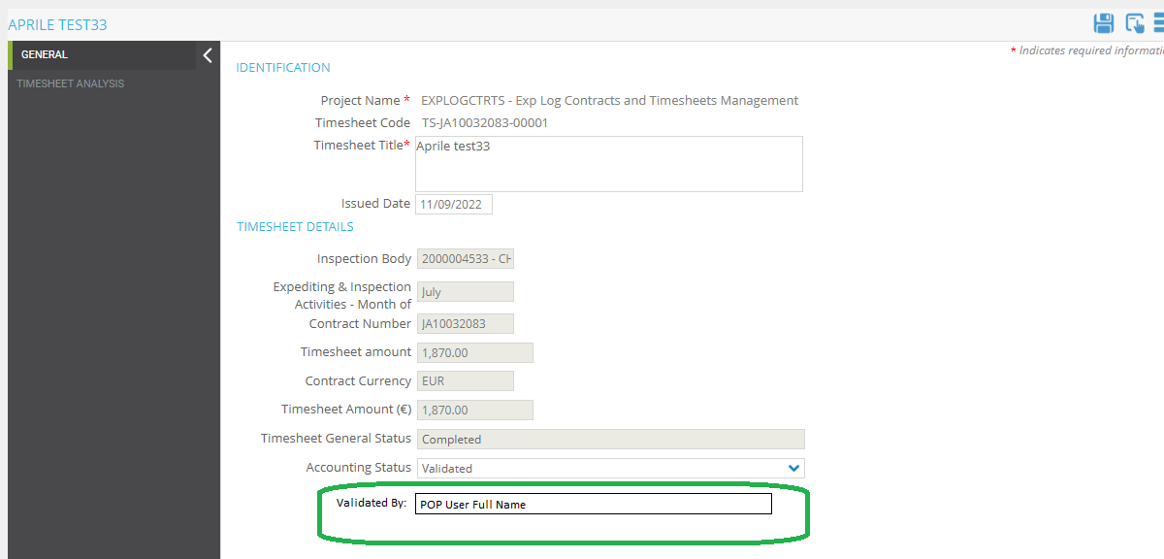

# Change Field in User Control Timesheet Details in TAB Timesheet Analysis

* **Implementation logic**

It is required by Enel to change field in user control **Timesheet Details** in tab **Timesheet Analysis** in **Timesheet** **Form**

* **General implementation requisite**

The Field **Country Inspection** should be changed in a Dropdown and connected to same data table of the Dropdown“**Country**” used in **Inspection** Form.

The Dropdown must have realtime search directly in the dropdown, same as Other dropdown in this UserControl.

This Change should also be made in the Excel Template. (from free text field to Dropdown with data as specified above).

# Modify logic for check (Field “Check Status”) in User Control Timesheet Details in TAB Timesheet Analysis

* **Implementation logic**

It is required by Enel to change the Logic of the Check (field “**Check Status**”) in user control **Timesheet Details** in tab **Timesheet Analysis** in **Timesheet** **Form**

* **General implementation requisite**

**At the moment the logic works as per previous requirement:**

The Check is used using the **EGP Code** to find the Related **Inspection** form.

**Logic** **AS IS:**

**Check Status** is **OK**

In Inspection Form

* the Field "**Reception Alert**" is flagged
* the Field: **N. days** for this record is equal to Field: "**Activity Duration (days)**" in **Inspection** Form

in any other case **Check Status** is **Not OK**

it is required to add more checks (more fields to be checked maintaining same logic) as follow **(in Green the new check to implement)**:

The Check is used using the **EGP Code** to find the Related **Inspection** form

**Logic**:

**Check Status** is **OK**

In Inspection Form

* the Field "**Reception Alert**" is flagged
* the Field: **N. days** for this record is equal to Field: "**Activity Duration (days)**" in **Inspection** Form
* the Field “**Country Inspection”** for this record is equal to Field: "**Country**" in **Inspection** Form
* the Field “**Type of Visit**” for this record is equal to Field: "**Inspection Type**" in Form Inspection (in inspection form is shown with the Code, in Timesheet without the code, so the check can be done checking description, or if not possible add code also in Timesheet dropdown for that field.( and in excel template)
* the Field “**Required by”** for this record is equal to Field: "**Expediting Specialist**" in **Inspection** Form
* - the Field “**Date of Visit”** for this record is equal to Field: " **Test Date** " in **Inspection** Form

in any other case **Check Status** is **Not OK**

**Related to this requirement, is it possible to identify (with different cell color) the cells that didn’t pass the check?**

**Otherwise, how we can implement something to identify the fields involved in the check? Tooltip on the Title of the Column “Check Status”? or coloring the Columns titles of the column affected?  
first option would be preferred (change cell color of the cell where the check was not OK)**